KS2 Snow Day Activities
Here are some fun and educational activities that you and your children could carry out on your ‘Snow Day’, should you so wish.
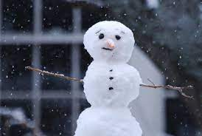
Maths: Build a snowman. This is a great opportunity for your child to work as a team and to use problem solving skills. Can you create more than one and order by height? What about measuring the snowman in millimetres, centimetres or meters or can you make a symmetrical snowflake?
Maths Word Problems: Mrs Minty and Mrs Robertson built 27 snowmen in a field. Some of them melted. Then there were 15 snowmen. How many melted?
Some mittens were on the table. Ms Wilkinson picked up 15 of them and then there were 31. How many were on the table to start with? How many pairs of mittens did she have?
Miss Henry made 23 cups of hot chocolate last week and 54 cups of hot chocolate this week. How many cups of hot chocolate has she made altogether?
Mrs Wood had some pine cones and then Miss Mcloughlin gave her 25 more. Now she has 75 pine cones. How many did she have before?
The Corsham Titans hockey team is practicing for their big game. At the beginning of practice the team lined up and took 21 shots on their goalie. At the end of practice, they lined up again and took 62 shots. How many shots did the hockey team take in all?
Mr Newstead is keeping track of the amount of snowfall at a ski resort this month. So far it has snowed three times. The first snowfall was 20 centimetres. Last week there was a snowstorm that added 78 centimetres. The most recent snowfall was 25 centimetres. How many centimetres of snow has fallen?
English: How many words with 3 or more letters can you make using only the letters in:
Winter Wonderland You can use each letter only once. What is the longest word you can make?

Poetry: An acrostic is a poem in which the first letters of each line spell out a word or phrase. The word or phrase can be a name, a thing, or whatever you like. Usually, the first letter of each line is capitalized. This makes it easier to see the word spelled out vertically down the page.
Write an acrostic poem using a word related to winter or snow. E.g. SNOWFLAKE
To create an acrostic, follow these five easy steps:
1. Decide what to write about. 2. Write your word down vertically. 3. Brainstorm words or phrases that describe your idea. 4. Place your brainstormed words or phrases on the lines that begin with the same letters. 5. Fill in the rest of the lines to create a poem.
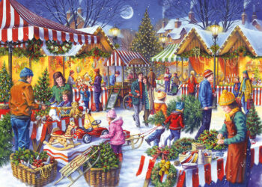
Writing: Write a story about the picture
- Who are the characters in the story?
- Where does the story take place?
- What is the weather like?
- What can the characters see, hear and smell?
- Is there a problem?
- How is the problem solved?
- Do the characters learn a lesson?

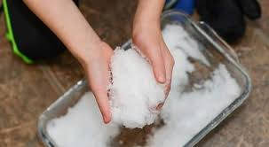
Science: Reversible and Irreversible changes: Experiment with the science of snow. Put some snow in a few bowls and conduct your own melting test. Where does it melt the fastest – on a radiator, in the fridge, under the bed? How long does it take to melt in each location? How will you record this? Can you evaluate the experiment and say how you would improve on it next time?

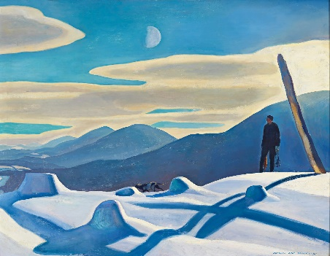
Art: Can you create your own snow based art work using a famous artist as inspiration? The first is by Claude Monet and titled ‘The Magpie’. The second is titled ‘The Trapper’ and is by Rockwell Kent, but you may have a different artist in mind.
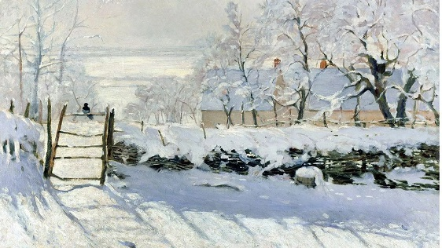

P.E: Draw a chalk target on an outside wall, line up some snowballs and shoot to score. Award different points for hitting different areas and keep tally with a score chart making sure to count in fives.
Computing: BBC Bitesize has a selection of Computer Science based videos and activities, as well as learning based on Information Technology and Digital Literacy. Take a look and tell your teachers what you find out. Always tell an adult if you are using a website, to ensure it is safe. https://www.bbc.co.uk/bitesize/subjects/zvnrq6f

Have fun and remember to bring any photos or art work from your snow day activities, to share with your teacher and your class!

