EYFS and KS1 Snow Day Activities
Here are some fun and educational activities that you and your children could carry out on your ‘Snow Day’, should you so wish.
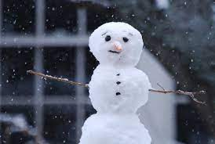
Maths: Build a snowman. This is a great opportunity for your child to work as a team and to use problem solving skills. Can EYFS count the number you build or the amount of stones you add ad button? Y1, can you create more than one and order by height? Can you make a repeating pattern using pebbles on your snowman? Y2 what about measuring the snowman in millimetres, centimetres or meters or can you make a symmetrical snowflake?
Creative Maths: Make gingerbread or shortbread biscuits into snowflake shapes and ice them with some white writing icing like the decorated biscuit. Take time to measure the ingredients, read the instructions and the scales when weighing out the ingredients.
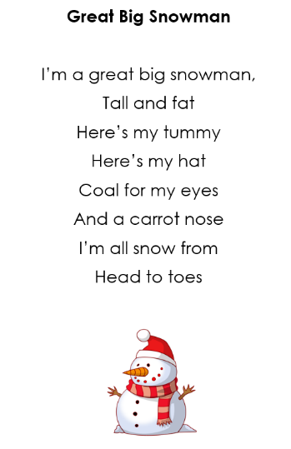
Writing / Phonics: Write a poem about the snow. These poems may inspire you…
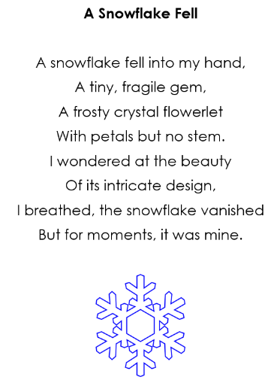

It could be a rhyming poem or it may focus on describing the snow and look like this:
Snow is ________________________________________________________________________ Snow is ________________________________________________________________________ It _____________________________________________________________________________

Or an acrostic poem, like this:
S___________________________________________ N___________________________________________ O___________________________________________ W___________________________________________
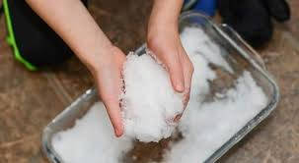
Science: Reversible and Irreversible changes: Experiment with the science of snow. Put some snow in a few bowls and conduct your own melting test. Where does it melt the fastest – on a radiator, in the fridge, under the bed? How long does it take to melt in each location? Once it’s melted, what happens if your put it back outside or in the freezer?

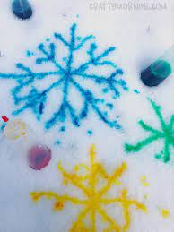
Art: Make some snowmen pictures. Use cotton wool and card and ask an adult to help you if you need to. Can you safely cut and stick your picture? Or you could make your own snow paint. Ask an adult to help you follow the instructions below:
- Mix ½ cup corn-starch and ½ water together in a bowl until it looks like milk
- Add in a few drops of food colouring and mix
- You can either put this into a cup to use with a paintbrush or a squeezy bottle to spray on to snow
Paper snowflakes are easy to make using only white paper and scissors. Make sure you cut very carefully and again ask an adult if you need help.

P.E: Draw a chalk target on an outside wall, line up some snowballs and shoot to score. Award different points for hitting different areas and keep tally with a score chart making sure to count in fives.

Computing: CBeebies have activities and learning games that your children will enjoy https://www.bbc.co.uk/cbeebies/games/cbeebies-the-night-before-christmas-game You can hear the story of the Nativity, join in with songs and play games. You will also find a selection of English (phonics and reading) and Maths games on the next site to keep you busy! https://uk.ixl.com/?partner=google&campaign=10065671434&adGroup=101521197056&gclid=EAIaIQobChMIwvXClcnF9AIVgGgVCB3TuAm8EAEYASAAEgLac_D_BwE

Have fun and remember to bring any photos or art work from your snow day activities, to share with your teacher and your class!

