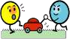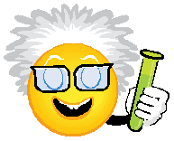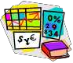

 | Science Skill | Year 1 & 2  Teacher models good practice in language and thinking | EMERGING | EXPECTED | EXCEEDING
Asking the  question | Asking the starter question | Teachers encourage pupils to generate questions (teachers model)
Asking the  question | Collect data:  What are we measuring or observing? | We can talk about what we are going to look/listen for… (Year 1)  We can talk about what we are going to measure… (Year 2)
Asking the  question | Ask a questions (which could lead to a fair test) | What do you think will happen to X if we …? (Year 1)  What do you think will happen to X if we change Y? (Year 2)
Asking the  question | Planning | This is the equipment/information we need for our investigation (teacher selects)
Collecting data | Gather evidence | Use our senses and simple equipment to describe what is around us (Year 1)  We can measure things with help from our teacher (Year 2)
Collecting data | Sorting and classifying | Using our senses we can tell our friend what thing are like (Year 1)  We can compare things (objects, living things, materials) and with help can decide how to sort and group them (Year 2)
Analysing data and drawing conclusions | Noticing patterns and relationships | We noticed…happened/changed when…(Year 1)  We thought this might happen…and the surprise was that…happened (Year 2)
Presenting  findings | Record findings | We can talk about what we have found out using simple language (template given by teacher)

Date Last Assessed | Year Group

