Helping concentration: Parenting Top Tips


Tip 1: Stay positive and healthy yourself
Maintain a positive attitude.
Keep things in perspective.
Don’t become stressed about little things and be willing to make some compromises Believe in your child.
Take breaks.
Take care of yourself.

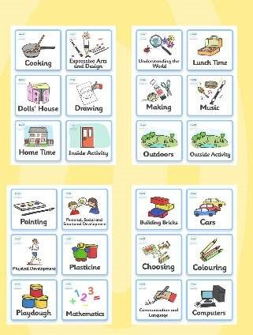
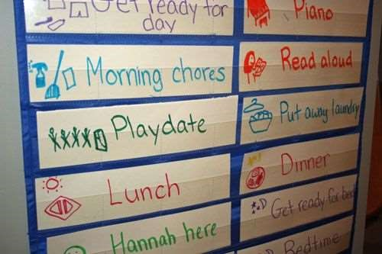
Tip 2: Establish structure and try and stick to it

Follow a routine.
Use clocks and timers.
Simplify your child’s schedule.
Create a quiet place.
Do your best to be neat and organized.
Avoid problems by keeping children busy

Tip 3: Encourage movement and sleep
It is likely children will spend some time on screens during the day- especially for parents who are trying to work, but set limits and try and stick to them.
Eliminate caffeine from your child’s diet.

Create a buffer time to lower down the activity level for an hour or so before bedtime. Find quieter activities such as colouring, reading or playing quietly. The light from screens interferes with our sleep patterns so avoid those at this time.
Spend ten minutes cuddling with your child. This will build a sense of love and security as well as provide a time to calm down.
Use relaxation tapes as background noise – Alexa/google has loads to choose from

Tip 4: Set clear expectations and rules
Be on the lookout for good behaviour—and praise it. PRAISE, PRAISE, PRAISE!

Rewards
Reward your child with privileges, praise, or activities, rather than with food or toys.
Change rewards frequently. Children with poor concentration get bored if the reward is always the same.
Make a chart with points or stars awarded for good behaviour, so your child has a visual reminder of their successes.
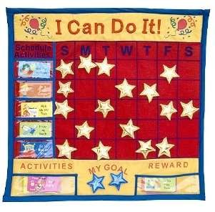
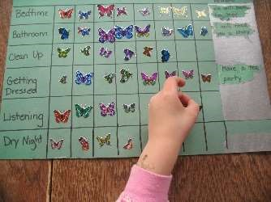
Immediate rewards work better than the promise of a future reward, but small rewards leading to a big one can also work.
Always follow through with a reward.

Tip 5: Help your child eat healthily
Food can and does affect your child’s mental state, which in turn seems to affect behaviour. Monitoring and modifying what, when, and how much your child eats can help concentration and attention.
All children benefit from fresh foods, regular meal times, and staying away from junk food.
Prevent unhealthy eating habits by scheduling regular nutritious meals or snacks for your child no more than three hours apart.

Tip 6: It’s not school
If your child is not keen to do ‘school’ at home, make sure to tackle learning activities in short sessions (30-45 minutes maximum) and remember that this is an unusual and stressful situation for everyone.
If it’s not working, take a break and bake something (lots of maths); share a book (literacy); play a board game (social skills); put on a wash (life skills) or get outside for some fresh air (if possible). Not everyday will go to plan and that’s okay.

