**Home Learning**

**Year 2 – Term 5 Week 4-Week beginning 11th May 2020**

**Reading:**

Try and read a few pages every day.

Over the week:

* Look at the front cover of a book and make a prediction on what you think the book will be about. Think about where the story might be set, the characters you think may be involved in the story and what you think will happen. Use the following sentence stems: **I wonder if…., I think that…, I imagine……, I predict… because…**
* As you are reading your book, ask the person you are reading to to ask you some questions about the book (using sentences beginning with **who, what, when, where, why & how).**
* Once you have read your story, tell an adult about what you have read.

Think about the key points or events that happened within your story and include these in your summary.

**English:** The Great Kapok Tree by Lynne Cherry

***WALT: think about different points of view.***

Imagine you are interviewing one of the animals in The Great Kapok Tree. What questions could you ask? What might their answer be? Write a question (ending with a ?). Write what you imagine the animal would answer in a sentence, ending in a full stop. Remember your capital letters too!

***WALT: write effective sentences***

Imagine you are one of the animals in the Great Kapok Tree. What might you see? Hear? Feel? What do you think about the rainforest? Choose an animal. Write this as your heading. Write sentences from the animal’s viewpoint. Can you include adjectives, effective verbs, using a connective, adverbs, similes to write the best sentences you can.

***WALT: read information and make notes***

Find out facts about an animal, using any animal non-fiction books you have or information you can find on the computer. Record notes in a way that you can use tomorrow to write sentences from. Challenge: Use questions as subheadings.

***WALT: write information sentences.***

Write a ‘fact file’ about your animal.

• Use a heading

• Organise information under subheadings

• Write in sentences using capital letters, full stops and finger spaces.

• Add detail and use effective words.

• Add non-fiction features (this could be bullet points/ diagram & label/ picture & caption/ fact box)

***WALT: write in sentences using homophones***. Use this week’s spellings in sentences, using correct punctuation and spelling.

Phonics/ Spellings- How did you get on with your spelling test last week? Are there any words you need to go back to to practise? This week we are looking at words that sound the same but they are spelt a different way and have a different meaning. These are called ***homophones***. (Have a look at BBC Bitesize, KS1, English, Grammar).We are also practising some common word spellings. Learn the spellings in your group list. Practise using them in a sentence, remembering to use capital letters and full stops. Have your test at home at the end of the week after you have practised your spellings a few times.

Group Two

1. sea
2. see
3. blue
4. blew
5. one
6. won
7. son
8. sun
9. new
10. knew

Group One

1. flower
2. flour
3. knew
4. new
5. whole
6. hole
7. hear
8. here
9. there
10. their

Group Three

1. the
2. then
3. that
4. here
5. there
6. find
7. kind
8. door
9. floor
10. poor

**Maths-**

* **Go to [www.whiterosemaths.com/homelearning/](http://www.whiterosemaths.com/homelearning/) More Addition and Subtraction work.**

Unfortunately, White Rose have decided to charge for their worksheets from now on which is somewhat disappointing! So we have paid for the premium worksheets for Year 2 and they are on the class page too. **There is no need for you to pay White Rose for any resources.**

**Click on Year 2, week 4 . Watch the video, try the questions-watch out, the more you do, the harder they get!**

* Practising Money problems.

Monday- Practise multiplication at the sweet shop. Pick the worksheet that’s best for you.

Tuesday_ Money puzzles-thinking caps on!

Wednesday Half price sale and/or giving change

Thursday Make the same amount from different coins

Friday Set up a shop at home! Put price labels on different tins or packets. ‘Buy’ 1 or 2 items and give the correct amount of money or get the right amount of change. Send us a photo of your shop!

* **Mental Maths**

Superfast money questions-adding 2 amounts, subtracting 10p or 20p from different amounts, working out how much change from 20p, 50p, £1?

Tell the time –What will the time be in quarter of an hour? Start at any time!

Add 3 numbers together eg

3 + 4 + 13 23 + 13 + 4 10 + 25 +15 11 + 11 +18

**Don’t forget you can log in to Professor Assessor and we will be able to see your results!** [**https://www.prof123.co.uk/**](https://www.prof123.co.uk/)

**A Reflection on the year so far: Please answer these questions and send them into us at school. (Your parents can type your answers or you can write them). Please send to:** [**admin@st-patricks.wilts.sch.uk**](mailto:admin@st-patricks.wilts.sch.uk)**. Thank you.**

**Year Two: My experience so far...**

1. What have you enjoyed learning about?
2. What have you worked hard at improving in your learning?
3. What do you want to get better at now?
4. Who do you play with when you are at school?
5. Who would you talk to if you had a problem at school?
6. What do you like about assemblies?
7. What do you like about Mass?
8. Have you been to Rosary? Have you been to any of the Stations of the Cross?
9. What do you like about RE lessons/ footsteps in faith?
10. Do you belong to any clubs? (either in school or out of school) Do you have any other hobbies or special interests?
11. What responsibilities have you had in class?

*Prayer leader/ locker monitor/ light monitor/ door monitor/ book corner/ table leader*

1. Is there anything else you want to tell Mrs Robertson or Mrs Tate?

**Science: Plants:** Visit virtual Kew Gardens ([www.kew.org](http://www.kew.org)). What different plants and flowers did you spot? Record some of your favourite ones either by drawing them or writing a list. Draw and label the parts of a plant (see BBC Bitesize, KS1, Science, Plants).

**History:** Florence Nightingale was born 200 years ago on Tuesday, May 12th. Amazingly she was the first to show how important nurses are, how infections can be slowed down by keeping patients apart and by making sure everyone washed their hands-things that are just as important for us today! In 2020, the new hospitals are named after her. What else can you find out about her? You could have a look at the information in this lesson plan.

<https://www.keystagehistory.co.uk/free-samples/florence-nightingale-lesson-plan/>

**Geography-** Find out facts about animals that live in the Amazon Rainforest- do they live in the canopy, understory, the emergent layer or on the floor? Mabel’s Powerpoint in the gallery will help you!

**RE:** Create a poster with the title **‘Prayer is talking to and listening to God’**. Make your poster colourful and joyful and try to include pictures of how, why and where people might pray. If you want to , you can write your own prayer too.

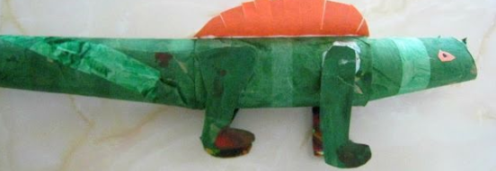Art : Make a rainforest animal using toilet roll/s for the body- you could use rolled up newspaper for legs and scrunched up paper for a head. If you’ve got the right glue, you could cover everything in papier mache, leave it to dry and then paint it in camouflage colours. Isaac has already made a snake that you can see in the gallery.

Don’t forget you can send a photo or scan of your animal that will get to us via [Sarah.Taylor@st-patricks.wilts.sch.uk](mailto:Sarah.Taylor@st-patricks.wilts.sch.uk)

**Music:** make a soundscape of sounds that you might hear in the rainforest. I’ve included some suggestions on my worksheet in the pack but you could think of your own. Use your voice, any tuned instruments you might have at home plus some kitchen utensils to make your own orchestra. (You may remember that we composed some music for the Great Fire of London like this).

**PSHE/Acts of kindness**

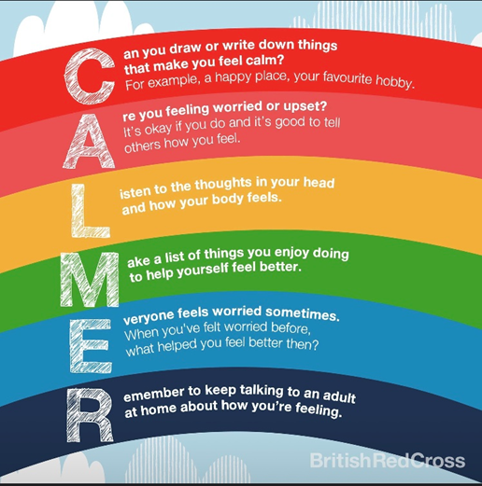

**PE**

Visit *The Body Coach* TV YouTube channel each morning at 9am as he will be providing a live PE at home lesson. <https://www.youtube.com/channel/UCAxW1XT0iEJo0TYlRfn6rYQ>

Play hopscotch and skittles as explained in the VE day pack.

**Useful Websites:**

<https://www.topmarks.co.uk/>- Maths and English interactive activities

<https://www.nhs.uk/change4life/recipes>- Cooking Ideas

<https://www.bbc.co.uk/bitesize/dailylessons>- Daily lessons for each year group. The maths fits in with White Rose Maths too <https://www.thenational.academy/>3 hours of online lessons daily.