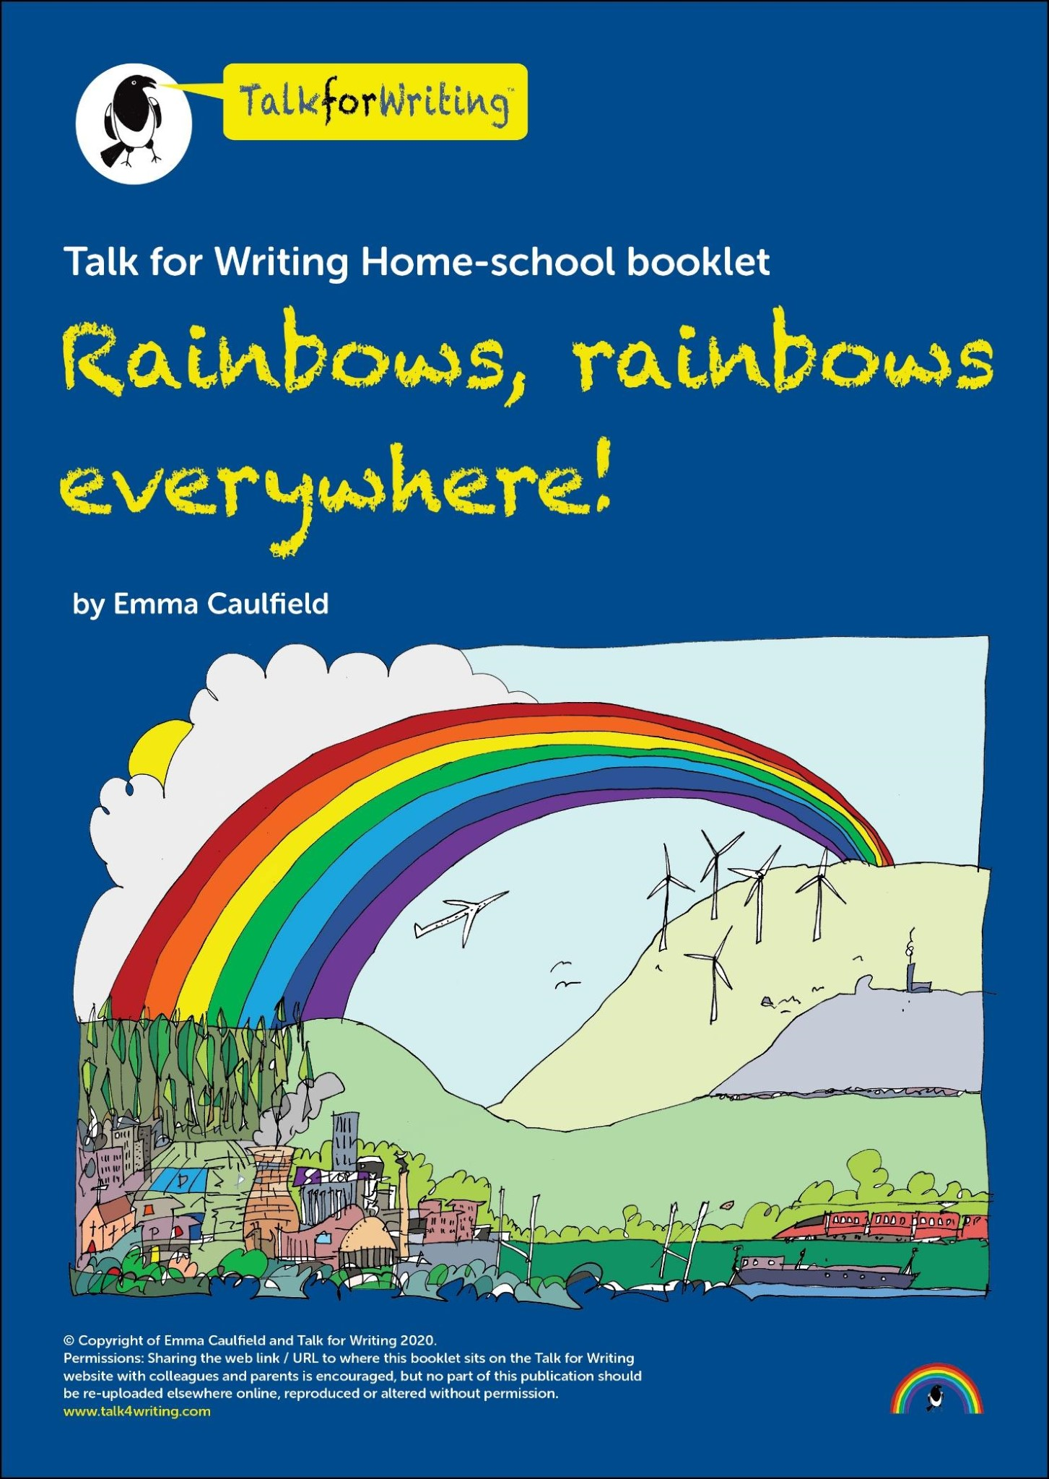

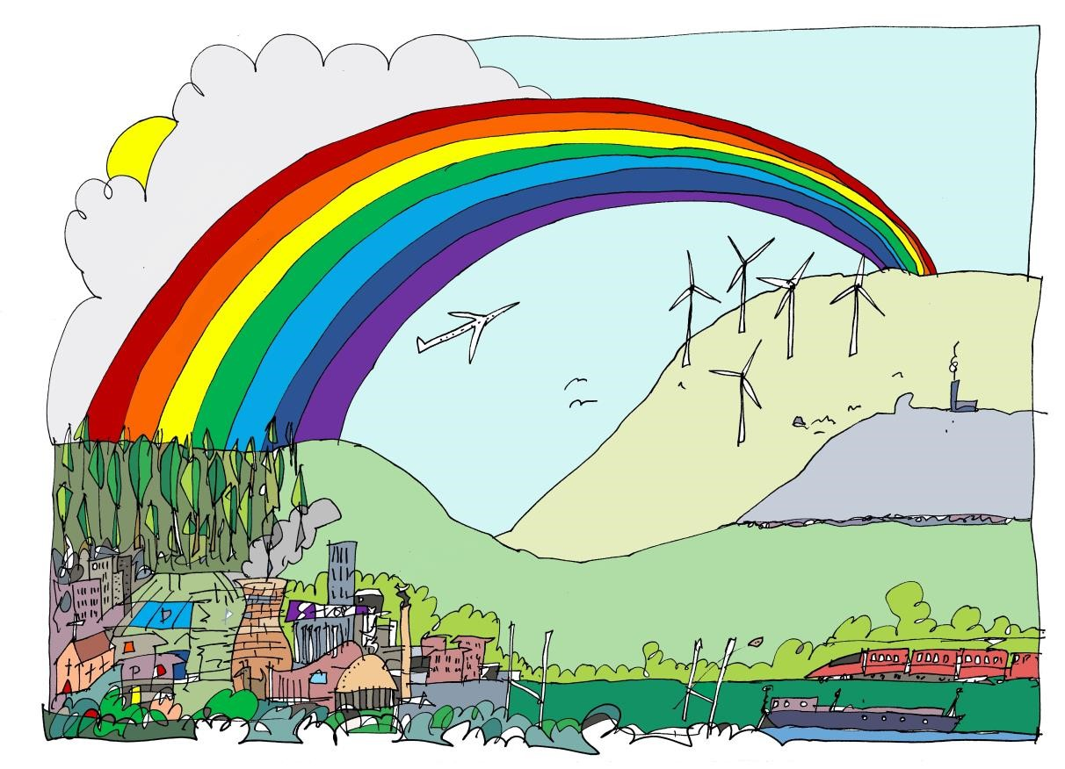

A riddle:
What am I?
A bridge, a bow, an arch.
Shining bright in the sky.
From sunshine and rain am I.
Look up or you’ll miss me.

Did you know that the rainbow is a sign of hope? In this booklet we will be looking at all things rainbow! Where they come from and why we are seeing more today, in spring 2020, than ever before.

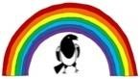

Dear Parent/Carer,

This booklet is designed for a child to work both independently and with a bit of support. All activities can be done alone, however there are some that will be more enjoyable for your child if you or someone else at home can join in.

The activities in this booklet are based on non-fiction texts and are on the theme of rainbows. We will be using our English skills to find out about and express the science of rainbows, explore the symbolism of rainbows and do some thinking about words, as well as some talk, some writing and some creativity!

At the end of the booklet, please support your child to rate and comment on how they got on with learning through this booklet.

The activities in this booklet are:


Talking about rainbows
Reading information texts
2 vocabulary challenges
Writing an information text
Word challenge
Reading an explanation text
Talk challenge
Creative challenge
Review

Written by Emma Caulfield

Have you ever seen a rainbow? Do you know where rainbows come from?

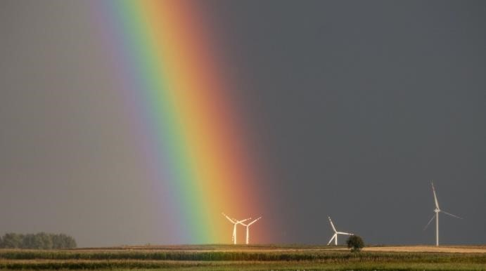

- Talk to someone at home about rainbows. You could talk about:

The colours that you can see (can you always see all of the colours like in the picture above?)
The shape of the rainbow (is it always an arc shape?) What is the weather like when you see a rainbow? And talk about this: (guess if you don’t know) How are rainbows formed?

Write down your ideas here:


The

colours

I

can

see

are

…

Rainbows

appear

when

…

The

shape

of

a

rainbow

is

…

When

there

is

a

rainbow

the

weather

is

always

…

- Read this piece of explanation with someone at home to find out about rainbows:

You can listen to an audio version of the text below here:
https://soundcloud.com/talkforwriting/rainbows/s-Mt28P9OJlXO

Rainbows

A rainbow is an arc of colour in the sky that can be seen when the sun comes out during or after a rainstorm.

How a rainbow is formed

A rainbow is formed when a person sees the sun or a light source shining through rain drops.

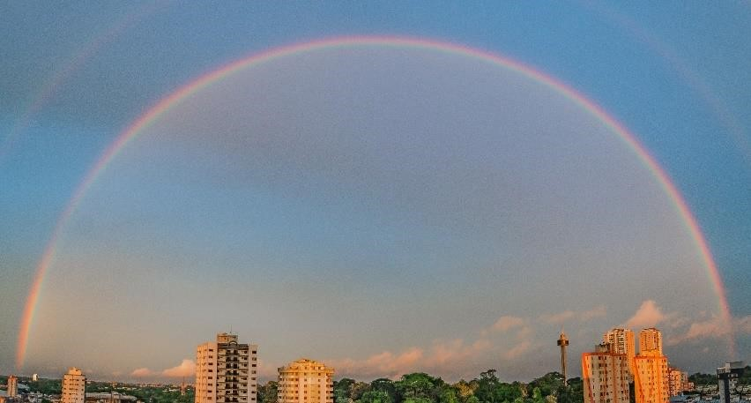
Photo by Italo Melo from Pexels

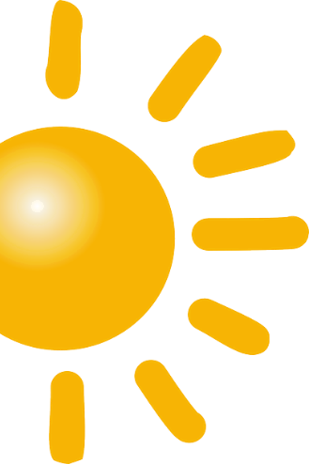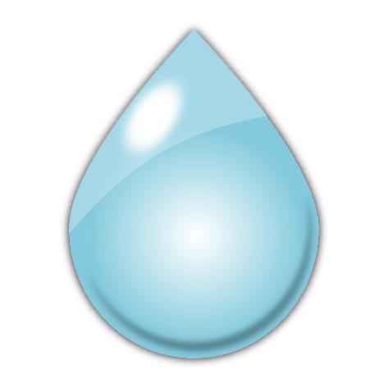
This

type

of

rainbow

is

formed

when

sunlight

strikes

raindrops,

at

a

forty

two

degree

angle,

in

front

of

the

people

looking

at

it.


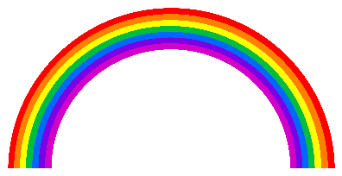

When

the

light

strikes

the

drops,

it

changes

and

splits

into

colours,

called

a

spectrum.

These

colours

are

bounced

back

to

us

so

that

we

see

a

rainbow.

What

we

see

The colours of a rainbow are red, orange, yellow, green, blue and purple.

Where are rainbows?

The rainbow is an optical illusion which means that it tricks your eyes so that what you think you see is different from what is really there. Rainbows are not in a fixed spot in the sky as the appearance of a rainbow depends on where the person seeing it is and where the light is.

Rainbows are actually full circles but viewers on the ground can only see them above the horizon.
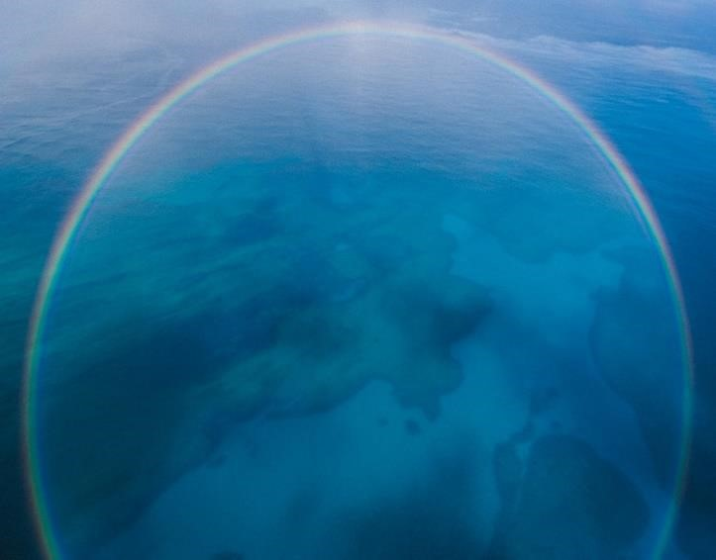

Photo

by

Jakob

Owens

on

Unsplash

Fascinating fact

A moonbow, also called a lunar rainbow, is a rainbow that is produced by light from the moon!

Glossary (what the words mean)

arc | A part of a line that forms the outside of a circle.
light source | The place or thing which you get light from.
horizon | The line in the far distance where the sky seems to meet the land or the sea.
spectrum | The range of different colours that you get when light passes through a glass prism or through a drop of water.

Now that you have read the information explaining about rainbows look again at the sticky notes you wrote on before. What have you learnt about rainbows? Fill in these sticky notes:


The

colours

I

can

see

are

…

Rainbows

appear

when

…

The

shape

of

a

rainbow

is

…

When

there

is

a

rainbow

the

weather

is

always

…

Vocabulary challenge

- Read the glossary and check that you understand the definitions

- See if you can do these mini-challenges:

- Use the text to help you to write your own definition of optical illusion

- Draw an arc
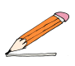

- Write down or draw as many light sources that you can think of:

- Use your careful looking skills to find the photograph on page 4 taken by Italo Melo. Find the horizon and show someone at home what the horizon is. Can you explain what it means?

Reading challenge

The text you have just read is an explanation text. It gives us facts about a topic and explains the causes of things. Most information texts have:

A title ❒

An opening sentence that says what the text is about ❒

A series of facts explaining why something happens ❒

Pictures and or diagrams ❒

Read the rainbow explanation text again and see if you can spot each of the items listed above. Tick the box when you find them.

EXTRA READING CHALLENGE

If you have any information or explanation books at home, or you are able to use a computer you could look at one of these websites:

https://www.natgeokids.com/uk/category/discover/ https://www.dkfindout.com/uk/

Use your scanning skills (read over the text quickly to find something) and see if you can find each of these in one book or on one webpage about something you are interested in:

- A title
- An opening sentence that says what the text is about
- Facts (information or explanation about something)
- Fascinating fact
- A glossary
- Photographs or diagrams

Write down what you have found

Title:

Opening sentence:

Key facts:

Fascinating fact:

One photograph or picture is of …

The diagram helps me know …

★ Finish your writing by reviewing the book or webpage What I liked about the book or webpage: ________________________

What I didn’t like: :
__________________________________________________

Questions I have: :
____________________________________________________

Writing challenge
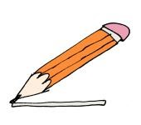
Your next challenge is to write about something interesting! It needs to be about something that you know a lot about.

Before we write we must think about what we are going to write about. Use the space below to write a list of things that you know a lot about (here are some ideas to get you started):

- whatever information you have just looked up
- your favourite sport
- cats/dogs or any type of animal you know something about
- any hobby or anything you are interested in
- your favourite television programme

- Choose your topic and then fill in this table to help you to plan your information text. Remember to only write short ideas or notes into your plan.

Rainbows plan | Basic plan | Example for Lego | Your plan
Rainbows | Title of text | Lego
Arc of colour in sky | Introduction | Type of plastic brick that you can make things with
How a rainbow is formed | 1st fact with some detail | How Lego works
Where are rainbows? | 2nd fact with some detail | What you can make with Lego
Moonbow | Fascinating  fact  (to end with) | More than 1000 world records for Lego

- You are nearly ready to write your text. Before you do, think about who your audience would be. Who are you writing this information text for? It might be someone at home or perhaps your teacher. Write down their name here:

Whilst you are writing, imagine that you are sharing your interest in the topic with them.

Writing challenge help sheet

Before you begin, check that you have:
- Chosen an interesting topic that you know a lot about. ❒
- Planned your text. ❒
- Chosen your audience. ❒

Remember, when we write we always:

- Say each sentence out loud before we write it.
- Think about our sentence as we write it.
- Start each sentence with a capital letter.
- Finish each sentence with a full stop (or other correct punctuation).
- Reread what we have written regularly to check it works and is correct.
- Try to do our best handwriting.

Words and phrases you could use to join your facts together:  and  also, in addition, |  | Words and phrases you could use to explain your facts:  because so/so that as when

Don’t forget to leave space in your writing for any pictures or diagrams.

★ When you have finished writing your information check it carefully:

- Read it aloud slowly, checking if the sentences make sense.
- Check your spelling.
- Slowly read it aloud (again). This time, check that you have remembered capital letters and full stops.
And, finally:
- Read (or send) it to your audience and ask them to tell you what they like about your piece and, perhaps, how you could have made it even better.

Word challenge

Look at the word r a i n b o w

- Write down other words that can be made using these letters
in, …

Did you find the words rain and bow? Do you know what a word that is made up of two words is called? (Check your answer at the bottom of this page.)

- Here are some other compound words that you may know:
football, playground, bedroom, airport, jellyfish, newspaper, outside, classroom. Let’s have some fun with them.

foot |  | ball |  |  |  |  | play | ground
bed |  | room |  |  |  |  | air | port
jelly |  | fish |  |  |  |  | news | paper
out |  | side |  |  |  |  | class | room

Your challenge is to use this list to make a new compound word and write a definition for it, for example jellyground – a boggy area where the ground is soft and wobbles when walked upon.

See how many new words and invented definitions you can create!


compound

word

- Read this explanation with someone at home to find out more about rainbows:

You can listen to an audio version of the text below here:
https://soundcloud.com/talkforwriting/why-rainbows/s-Ov4K1MVNQjn

Why is the rainbow an important image?

How do you feel when you see a rainbow? Maybe you marvel at the colours. Perhaps you wonder what’s at the end of the rainbow.
Rainbows have been important to people from the beginning of time. Read on to find out why.

Some people believe that the first time a rainbow was seen was by Noah. In the bible story of Noah’s Ark, a rainbow appeared which showed that the sun was coming out and the terrible storm was over. The rainbow was a sign of hope.
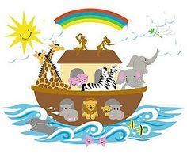
http://clipart-library.com/

In addition, rainbows are part of the myths of many cultures around the world. In Norse mythology, there is a rainbow bridge that reaches between Earth and the realm of the Gods. Rainbows were bridges in the ancient beliefs of Japan and Gabon, too. Therefore, the rainbow was seen as important to human happiness.

There is also a famous Irish legend about a pot of gold at the end of a rainbow that is guarded by a leprechaun. As the pot of gold has never been found, there is the hope that it will be … one day!
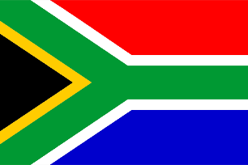
In South Africa, the rainbow was used as a symbol of hope and peace after a long period of white and black people being separated by their skin colour ended. To encourage everyone to come together, no matter where they were from or what colour their skin was, famous religious leader Archbishop Desmond Tutu called South Africa a ‘rainbow nation’. The South African flag has six colours which is believed to be linked to the ‘rainbow nation’ idea.

Today, all over the world, the rainbow is a symbol of hope and peace.

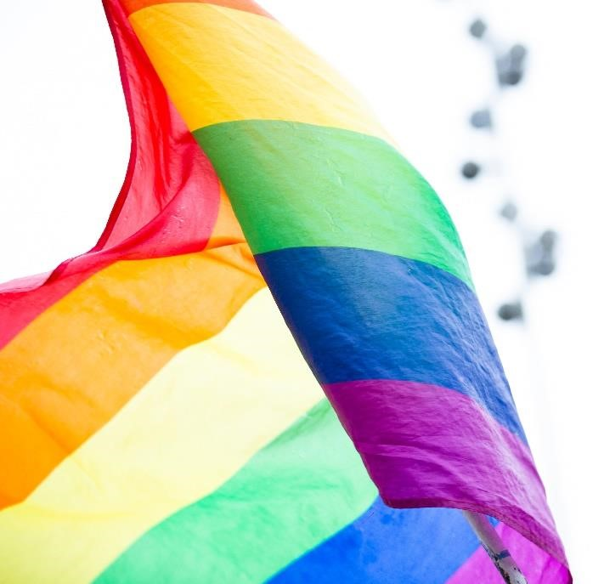
It is believed that the spectrum of colours represents difference and the beauty of everyone being different to one another. Celebrating and enjoying difference leads to peace (no arguments or wars).

The rainbow appearing in the sky is a sign that the storm is over which is why people see the rainbow as a sign of hope: hope for a sunny day and better things to happen in our world.
Photo by Markus Spiske from Pexels

Talk challenge

- Talk to someone at home about the rainbow and why it is important to some people. Here are some ideas of things to talk about:

▪ What ideas do you have about the rainbow as a symbol?

▪ What else have you seen the rainbow or rainbow flag used as a symbol for?

▪ If you were writing this explanation what other information would you have included?

- Have you seen any rainbow pictures in people’s windows? Perhaps you have one in yours! Imagine that an alien has just landed on your street or near your home and has asked you why people are displaying rainbow pictures in their windows. Think about what you would say and then have a go at explaining why there are rainbow pictures in people’s windows.

You may find these sentence starters help you:

At the moment, there is an illness … Rainbows represent …
People display rainbow pictures to …
Rainbow pictures make people feel …
When people see the rainbows they …

Talk super-challenge

- When you are happy with your explanation, why don’t you record it? You could use the voice record function on someone’s phone (remember to ask permission).
- Listen to your recording and see if there’s something you could improve. Think about how clearly you are speaking and whether your voice sounds interesting to listen to. If you are allowed to, you could publish your recording on Twitter! Don’t forget to tag us @Talk4Writing.

Vocabulary challenge

★ Can you guess or explain what these words mean? Each of them is in bold in the explanation text above. Find them, read the sentence that they are in and guess or explain what each one means.

- marvel – Maybe you marvel at the colours.

- myth – rainbows are part of the myths of many cultures around the world.

- realm – the realm of the Gods.

- legend – a famous Irish legend about a pot of gold at the end of a rainbow.

- leprechaun – that is guarded by a leprechaun.

- Symbol – the rainbow was used as a symbol of hope and peace.

- Represents – the spectrum of colours represents difference. ★ Here are the definitions and explanations of each word. Read each one carefully and check your ideas. Colour one of the emojis:
Right 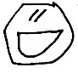 nearly right 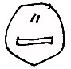 wrong 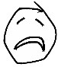
- Marvel – when you marvel at something you show you feel happy and surprised.
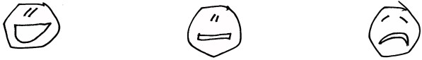
- Myth – a myth is a well-known story that was made up in the past.

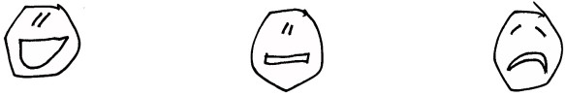
- Realm – a realm is a country with a king or a queen.

- Legend – a very old and popular story that may be true.
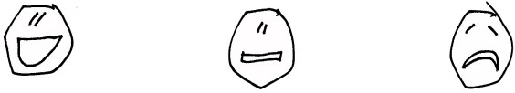

- Leprechaun – an elf that likes to get up to mischief.

- Symbol – a symbol is a shape or design that means something. For example, a full stop is the symbol that means it’s the end of a sentence.

- Represents – if a sign or symbol represents something, it is known to
mean that thing. For example, a full stop represents the end of a sentence.
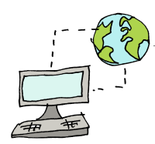https://www.collinsdictionary.com/ was used to create these definitions.

Make it challenge

This challenge is all about making rainbows! It is up to you what you make and how you make it, as long as it includes a rainbow.

Ask someone at home to help and always ask before you do things like cutting up magazines, using glue or scissors.

Here are some ideas:

- Use something shiny and a torch to make rainbows on a piece of paper or white wall.

You will need: a CD (ask an adult) or something really shiny, the sunshine or a torch and a piece of paper or a white wall.

What to do: shine the torch onto the CD and wiggle it around until you see rainbows. See if you can reflect the rainbows onto the paper or the wall.

- Make a rainbow collage.

You will need: lots of magazines or coloured boxes or paper; glue; piece of plain paper.

What to do: rip or cut up the magazine pictures, boxes or paper into piles of squares of red, orange, yellow, green, blue and purple. Arrange the coloured squares into a rainbow shape and then stick them onto the plain paper.

- Bake a rainbow

- Model a rainbow

- Build a rainbow

- Create one outside on a sunny day using the spray from a watering can or hose pipe (ask permission from an adult!)

Rainbows would like to know how you have got on with finding out more about them.

I would rate my journey through this booklet (tick hot or cold):
- If you tick near the top of the red thermometer, that means you really liked it.
- If you tick near the bottom of the blue thermometer, that means you really did not like it.
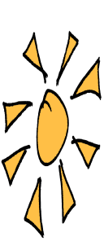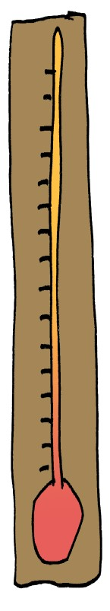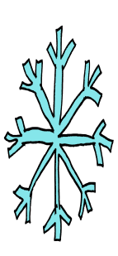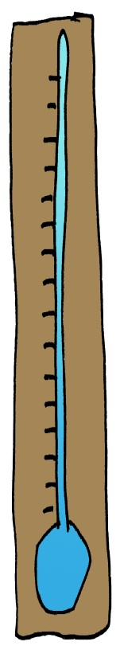

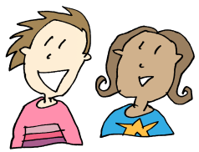

This

workbook

has

helped

me

learn

…

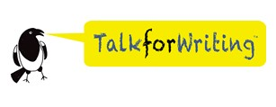

© Emma Caulfield for Talk for Writing
Emma Caulfield, former teacher and National Strategy Literacy Consultant, now works with Talk for Writing to help schools develop the approach.
Edited and designed by Julia Strong
Prepared for online distribution by Nick Batty

To find out more about Talk for Writing, visit www.talk4writing.com.

Thanks to Jon Ralphs for the cartoons: jonralphs.com
Permissions: Sharing the web link / URL to where this booklet sits on the Talk for Writing website with colleagues and parents is encouraged, but no part of this publication should be uploaded elsewhere online, reproduced or altered without permission.

