**Home Learning – Year 6**

**Week 2– Answers**

**Maths**

Daily Arithmetic

|  |  |  |  |  |
| --- | --- | --- | --- | --- |
| Day 1 | Day 2 | Day 3 | Day 4 | Day 5 |
|  |  |  |  |  |

Investigations:

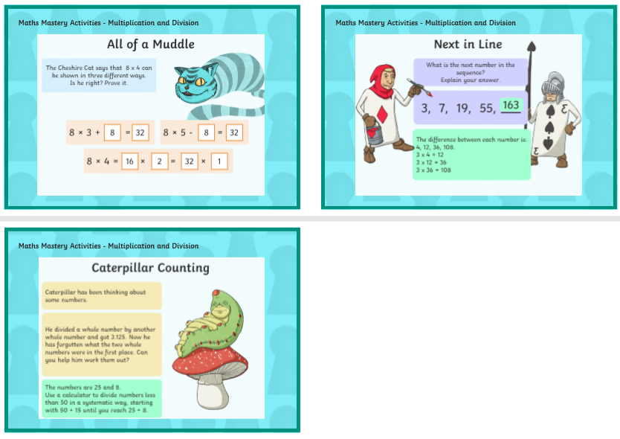

Day 4: 144 eggs

Day 5: 25% of 76 (19)

**English**

