Home Learning - ANSWER SHEET
Year 1 – Term 5 Week 2
27th April 2020

Reading:
Well done to all those who through there reading this week. Did you manage to find something a bit different to las last week? One of the great pleasures in life is reading a book in the garden on a summer day !

English:
Diary entry
Your diary is going to be something special to keep and look back on when you grow up. Have you been using your best handwriting? You want your grown up self to be able to look back and read those letters! Well done everyone!
Story writing
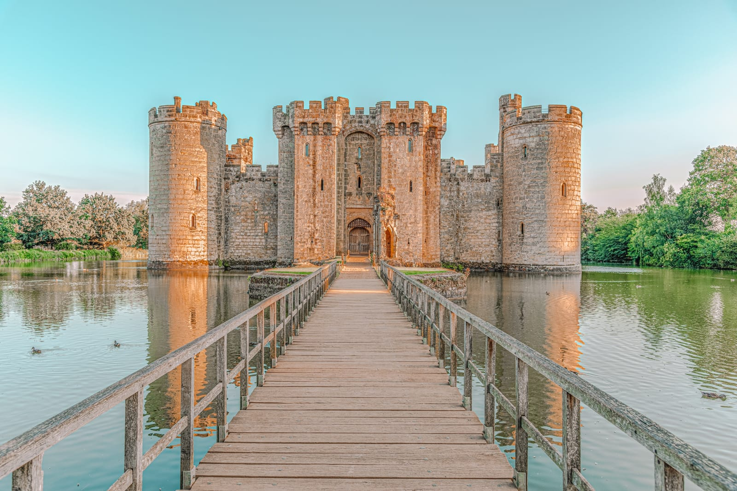
Have you sent us some of your writing for our virtual display board? We'd love to see it. Have a look at this checklist... did you manage to include all of these things?
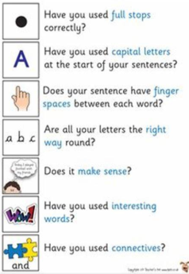

Spellings: Keep up the good work!

Phonics: We hope you managed to get connected to the online learning! Keep up the good work, the phonics progress you have all been making is excellent!

Maths:
Time: Fluency
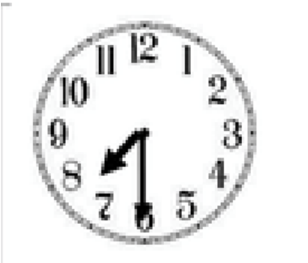
Look at the clocks below. Can you match the corresponding times for each? Use the sentence stems to help explain your choices. For example

Half

seven

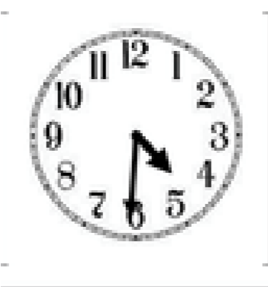
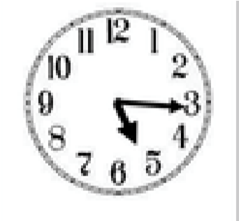
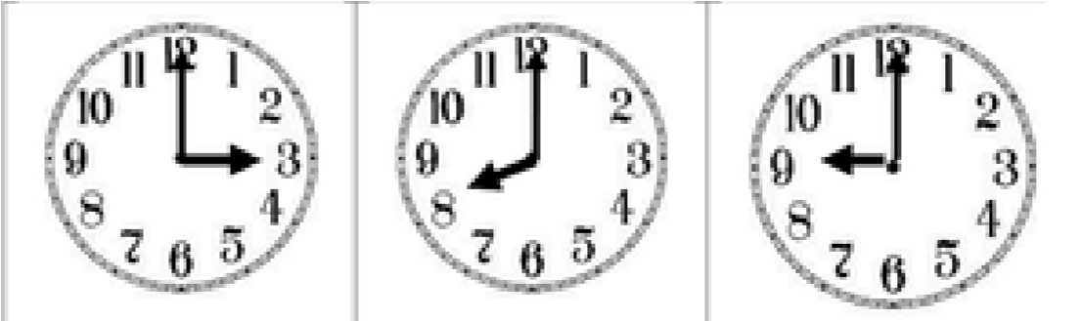
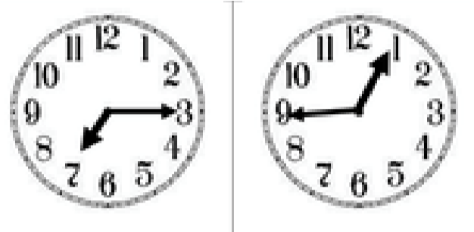
:

Half past six quarter to one eight o clock three o clock

Quarter past seven half past four nine o clock

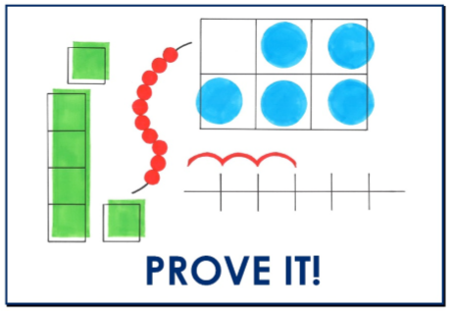
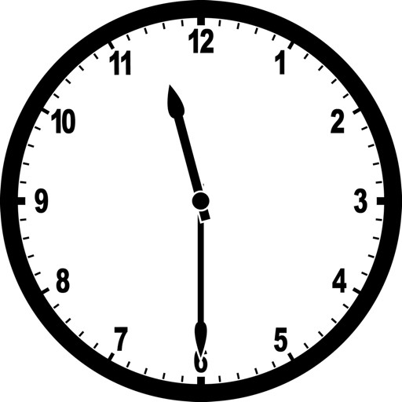

True or false?

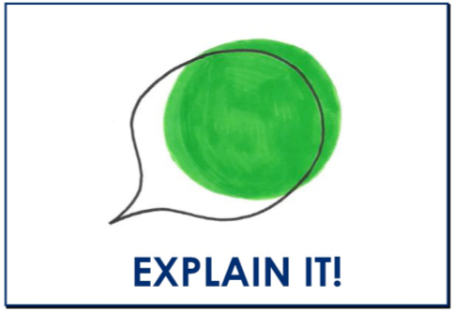
Which of these times is when you wake up? How do you know?
7am, 7.30am, 8am (or 9am!)
I know that… is when I wake up because it is light in my room and
people are out and about

Reasoning:
Mrs Sykes says that this clock shows half past 12.
False, the hour hand is not past the twelve. The time shown is half past eleven.

Application:
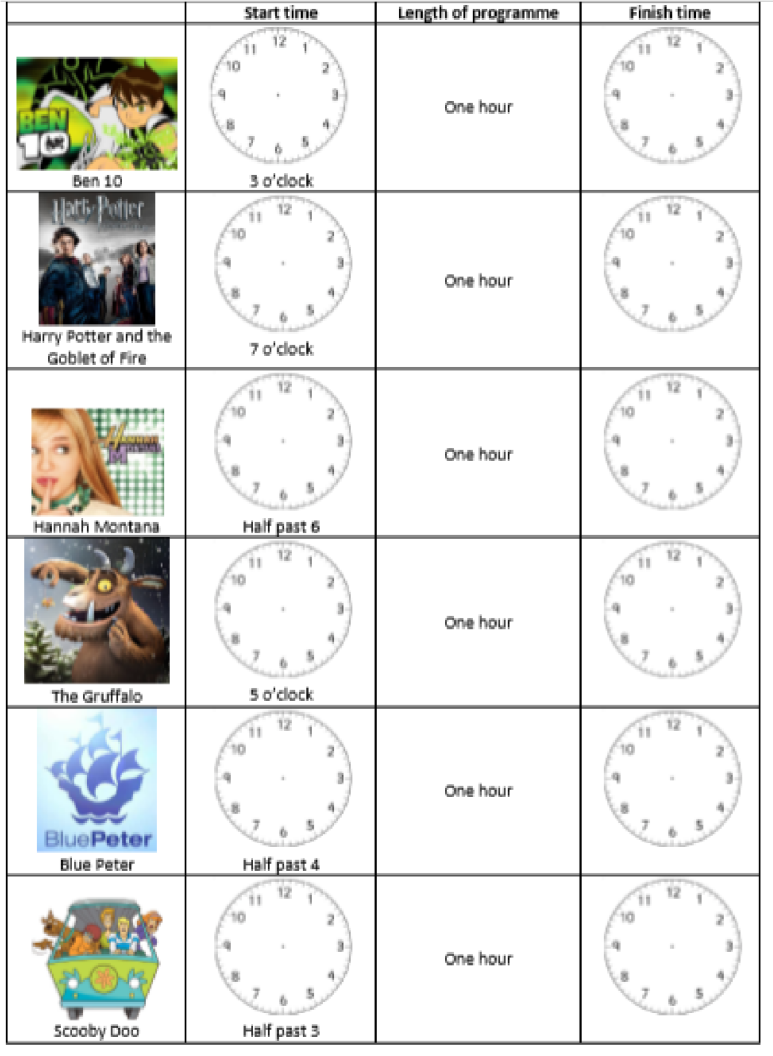
Now that you have practiced your time knowledge, here’s a timetable for Mrs Solomon’s TV shows. Can you fill in the start time and then the finish time?

Religion:
I wonder how the story of the resurrection made you feel?
Have you sent us any pictures of the Easter cards you have been creating? We'd love to see them.

Science:
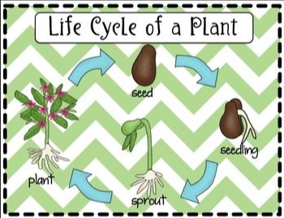
History: Kings and Queens!
I love finding out about history, especially the Tudors! Do you watch Horrible Histories? I used to read all the books when I was little...
My favourite Henry the 8th fact...
Henry wrote a number of songs, he was very talented! I wonder if a grown up can help you find one of his songs to listen to?
Well done - you are historians!

Geography: Where does my food come from?
A famers job is so varied and starts very early! If you were a farmer, would you want to be dairy farm? crops? animals? Farming is a very important job, have you ever wanted to be one?
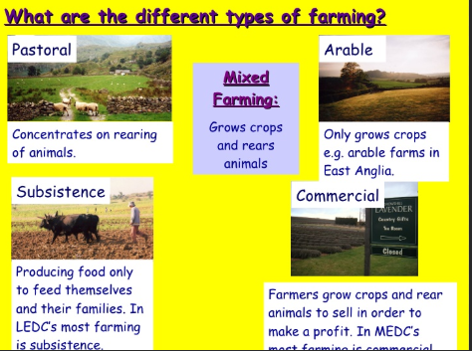

Art
We love seeing your art work! Well done all.

Grammar and Punctuation:
What is wrong with these sentences? Can you write them down and correct the mistakes.

how old are you! How old are you?

my name is bob. My name is Bob.

It was sunny and so i went outside It was sunny and so I went outside.

PE
Stay active everyone!

