Date ____________ WALT – read scales and record in kg

Draw the pointer on the scale to show the weight below.

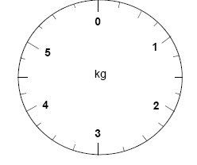
2kg 5kg 1kg

4 ½ kg 3 ½ kg ½ kg

2 ¼ kg 3 ¼ kg 1 ¾ kg

Date ____________ WALT – read scales and record in kg

Write the weights under the scales.

____kg ____kg ____kg

____kg ____kg ____kg

____kg ____kg ____kg

